FOC Documentation

Part 1

Set hostname to p2222291.

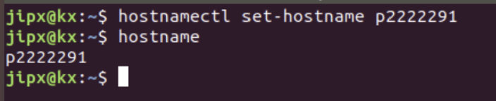

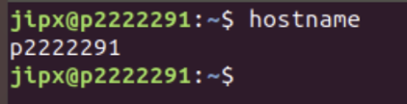

Part 2: Install Apache web server, PHP and MySQL server

Update Ubuntu.

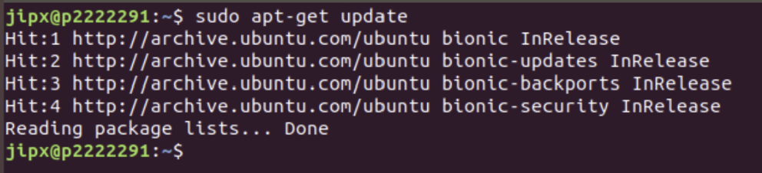

Install Apache2.

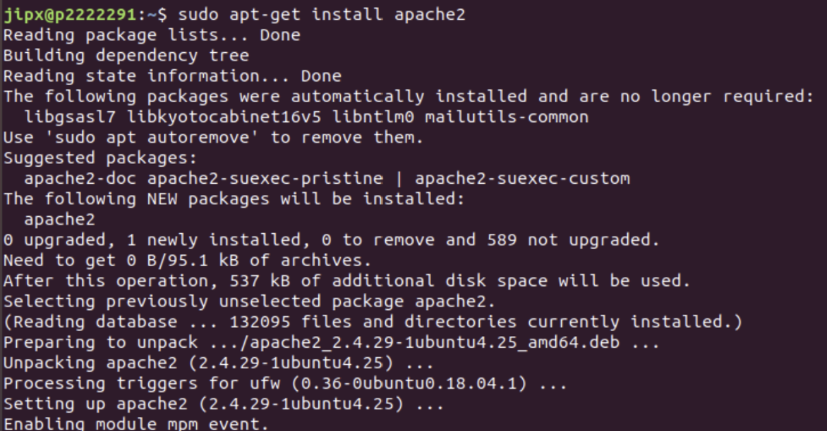

Ensure that status of apache2 is active.

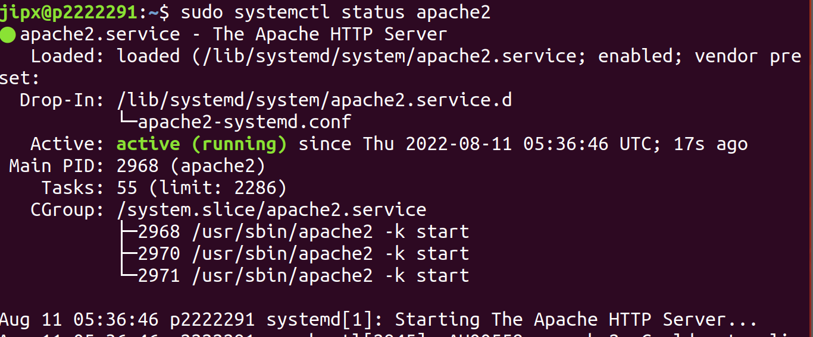

Install myPHP.

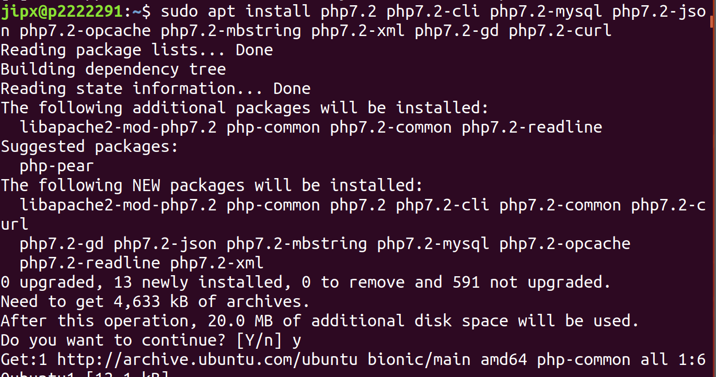

Ensure that myPHP is working.



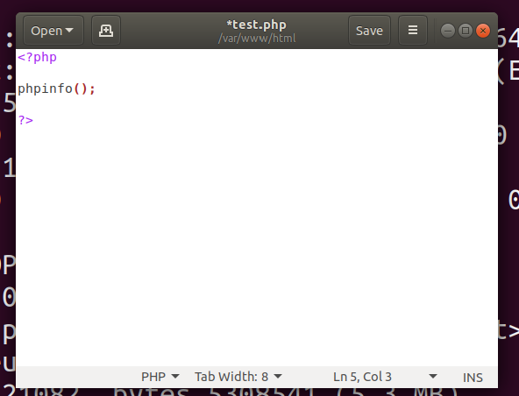

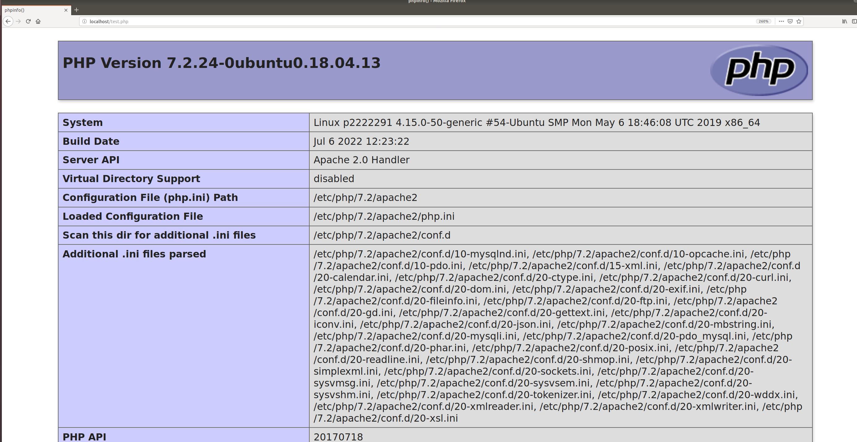

Remove the file as this test could give information about your server to unauthorised users.



Install mySQL.

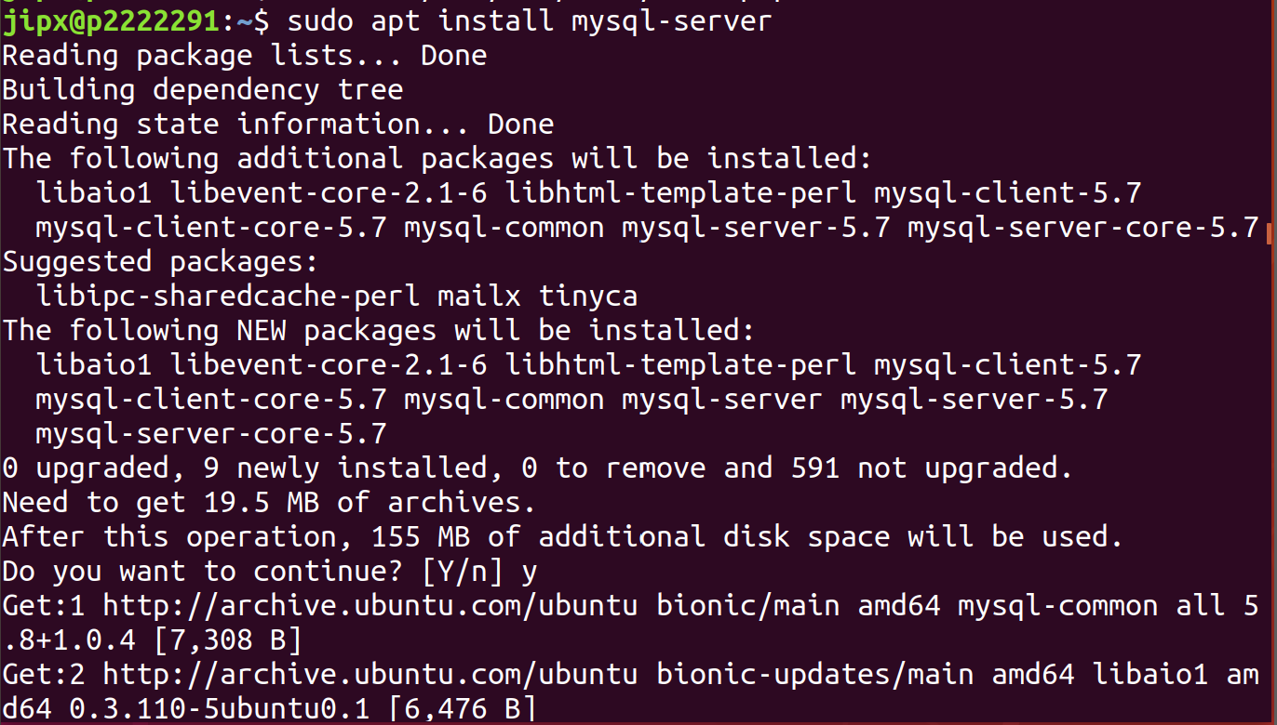

Ensure that status of mySQL is active.

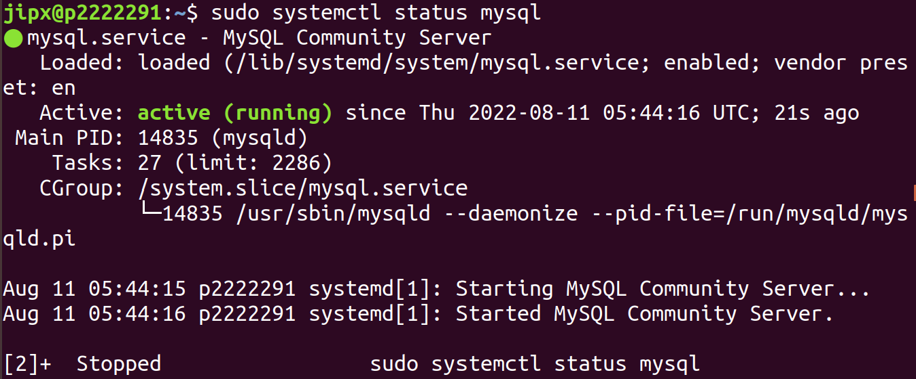

Run MySQL security script

1. Enter y, then press enter.
2. Press enter again to set default settings.
3. Next, enter your password.
4. Press y then press enter for the rest of the section to set default settings.

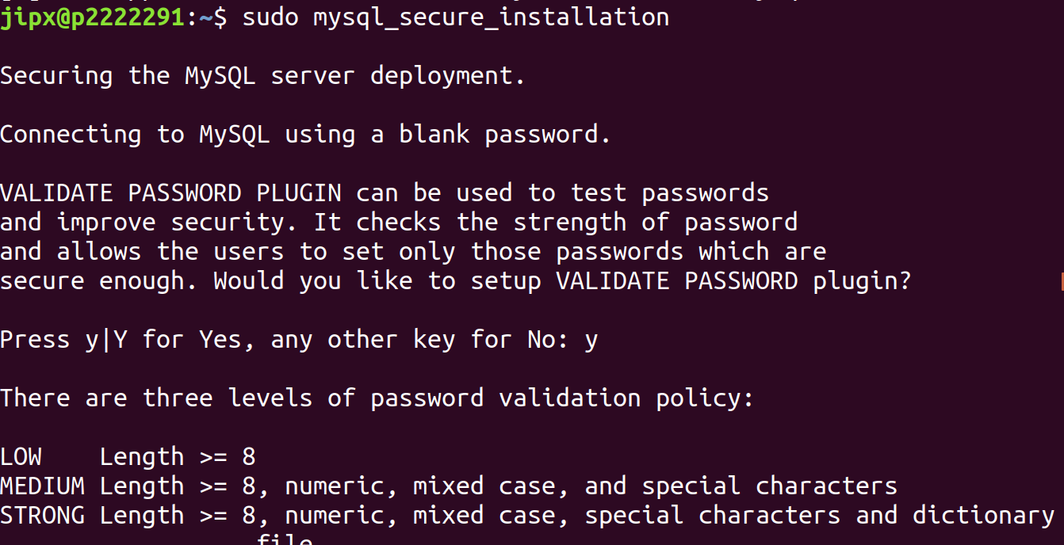

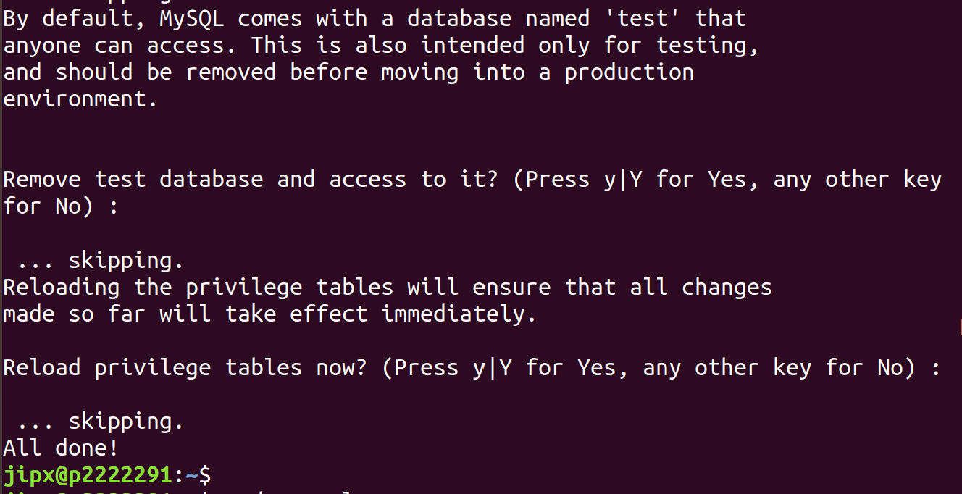

Part 3: Create Groups and Permissions

Add group webdev and sysadmin.

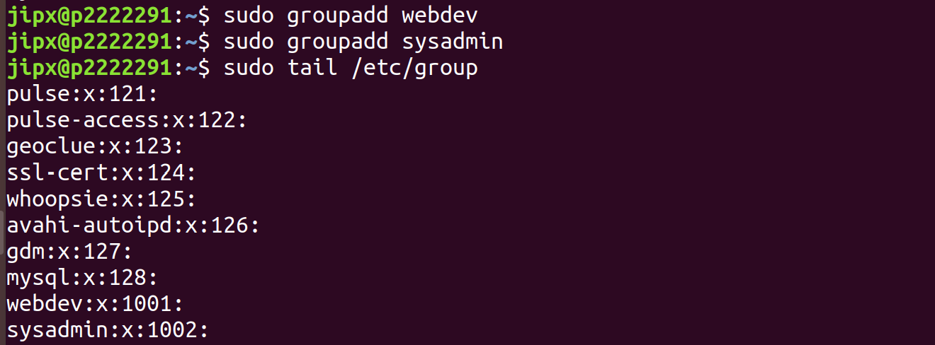

Add user sysadminuser1, then press enter for default settings until you see ‘Is the Information correct?’ then enter y.

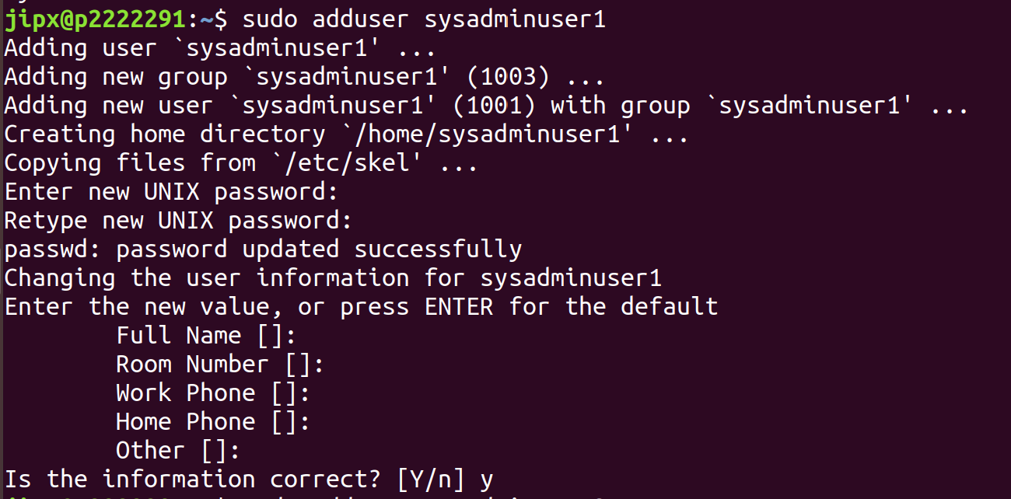

Add user sysadminuser2, then press enter for default settings until you see ‘Is the Information correct?’ then enter y.

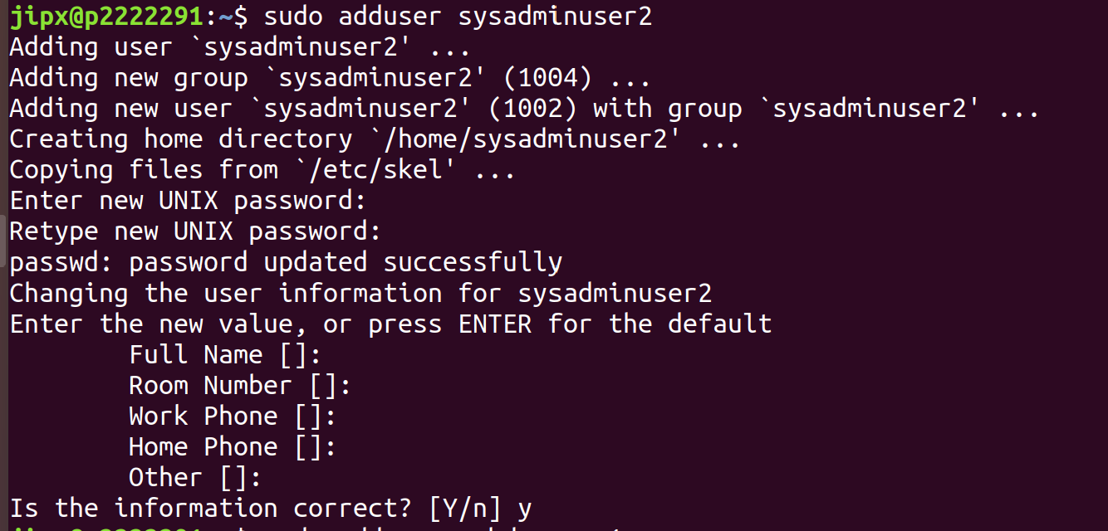

Add user webdevuser1, then press enter for default settings until you see ‘Is the Information correct?’ then enter y.

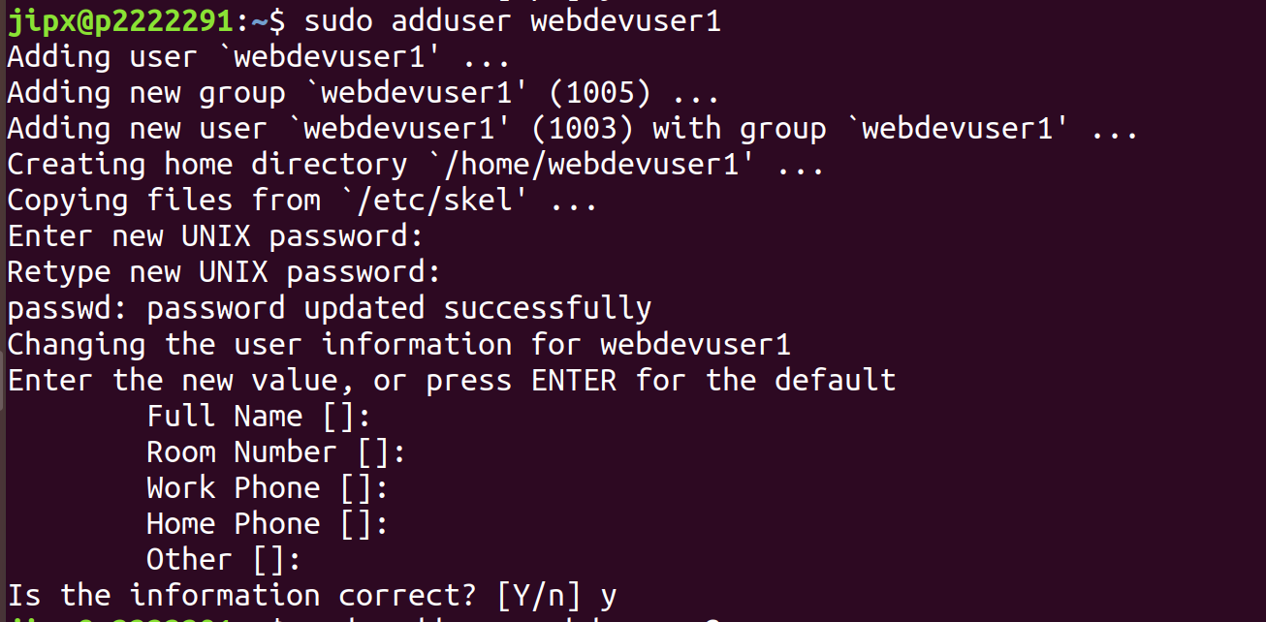

Add user webdevuser2, then press enter for default settings until you see ‘Is the Information correct?’ then enter y.

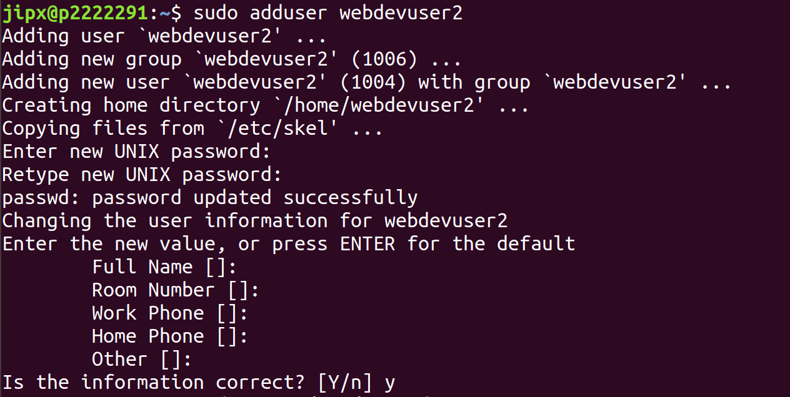

Ensure that sysadminuser1, sysadminuser2, webdevuser1 and webdevuser2 has been added

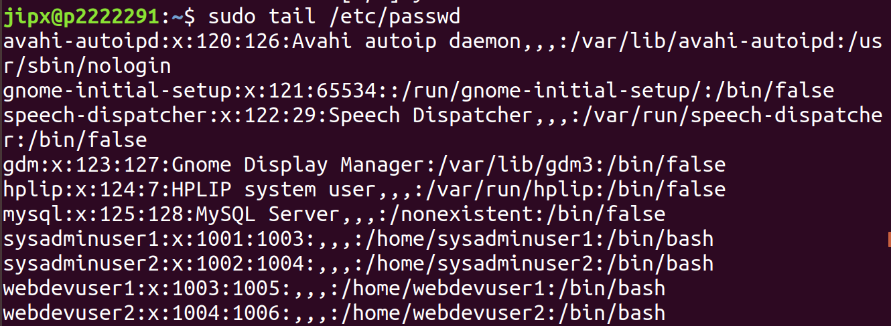

Add sysadminuser1 & sysadminuser2 to group sysadmin as well as adding webdevuser1 & webdevuser2 to group webdev.



Add sysadminuser1 and sysadminuser2 to sudo group.



Show that sysadminuser1 and sysadminuser2 have sudo power and webdevuser1 and webdevuser2 does not have sudo power.

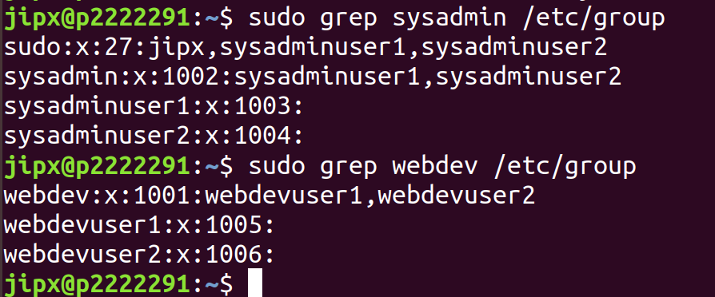

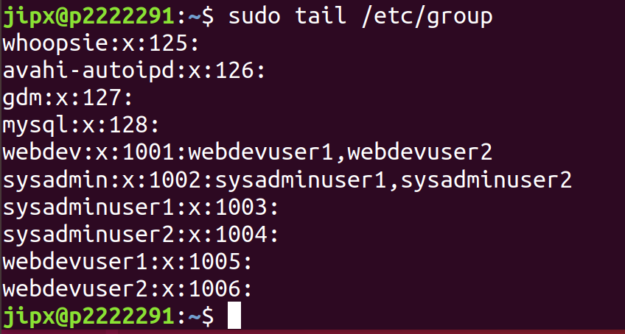

Verify sysadminuser1 & sysadminuser2 can run sudo command. Also, verify that webdevuser1 & webdevuser2 cannot run sudo command

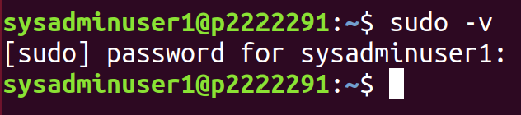

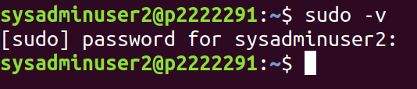

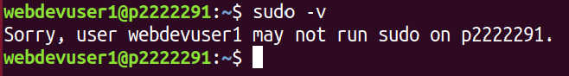

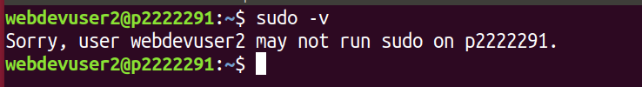

Part 4: Install, Configure and Monitor Wordpress Web site

Download package list to latest version.

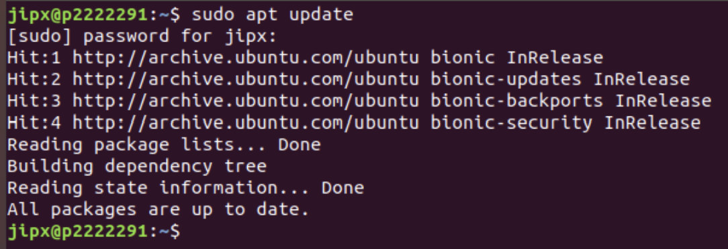

Start the database server and log into database server as the root user.

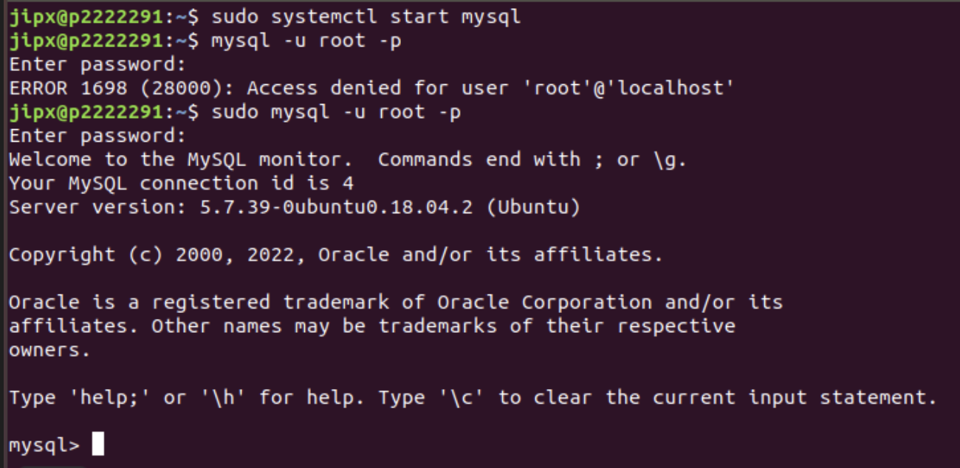

Create a WordPress user, followed by setting a password.

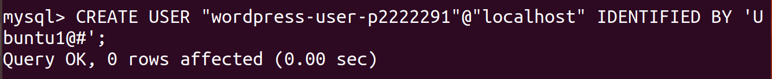

Verify that the WordPress user is created.

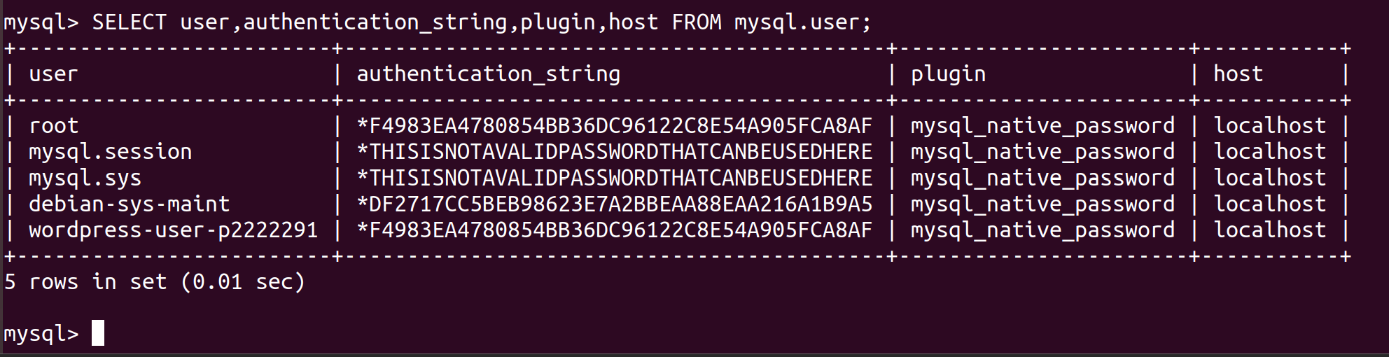

Create your database and give your database a meaningful name.

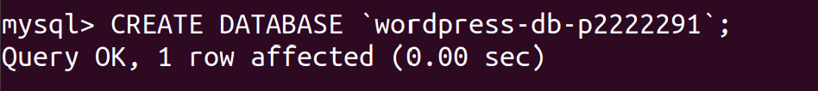

Grant full privileges for your database to the WordPress user that was created earlier.

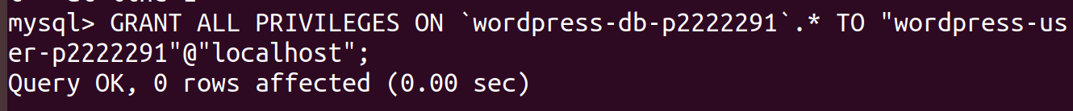

Flush the database privileges to confirm all the changes then exit MySQL.

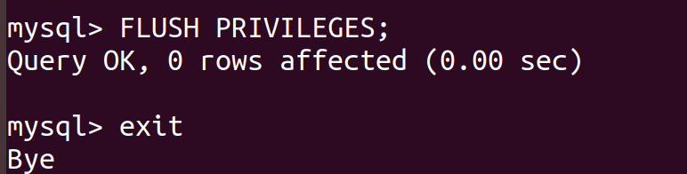

Install WordPress

Download WordPress Installation Package

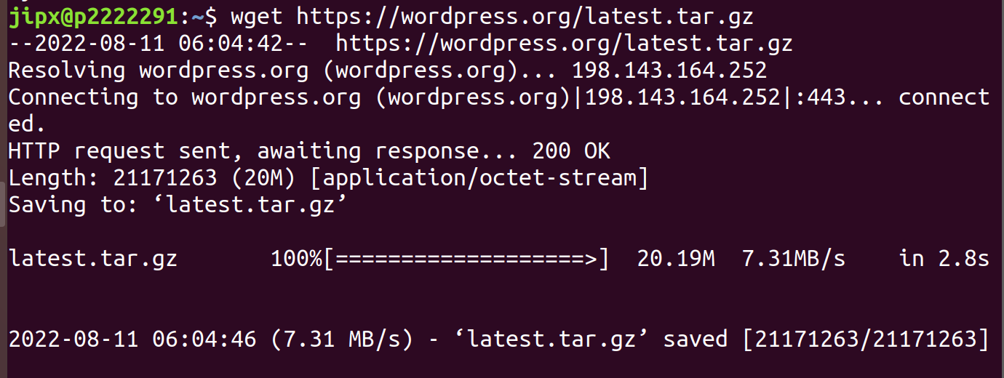

Unzip the WordPress Installation Package



Copy the wp-config-sample.php file to another file called wp-config.php



Edit the wp-config.php file



1. Find the line that shows define(‘DB_NAME’, ‘wordpress-db’); and enter your WordPress database name.
2. Find the line that shows define(‘DB_USER’, ‘wordpress-user’); and enter your WordPress user.
3. Find the line that shows define(‘DB_PASSWORD’, ‘your_strong_password’); and enter your WordPress password

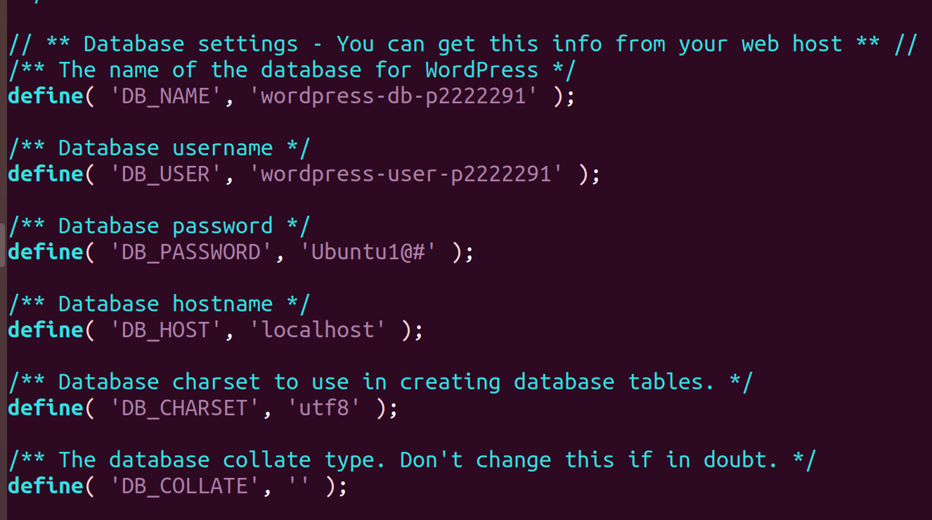

1. Find the section called Authentication Unique Keys and Salts.
2. Enter the URL <https://api.wordpress.org/secret-key/1.1/salt/> to generate a set of values to copy and paste into your wp-config.php file.
3. Save your file and exit your text editor.
4. To exit text editor, press esc, then :x

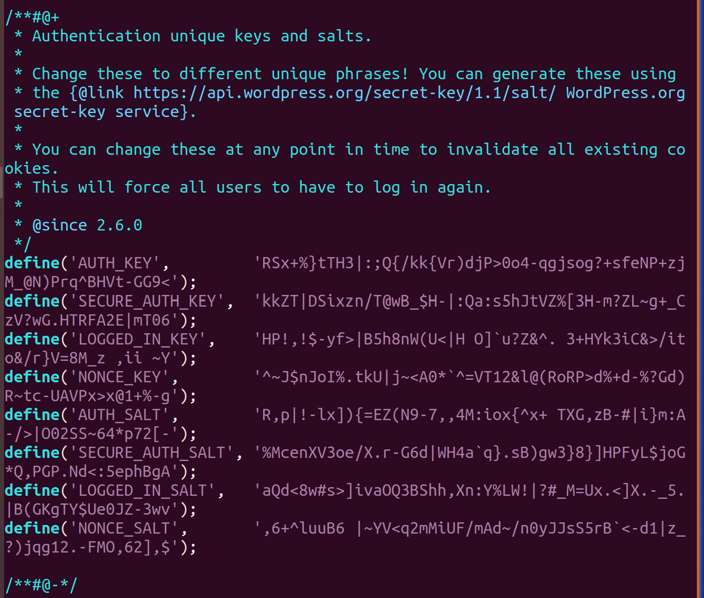

Create a directory then copy the files into that directory



Change Document root



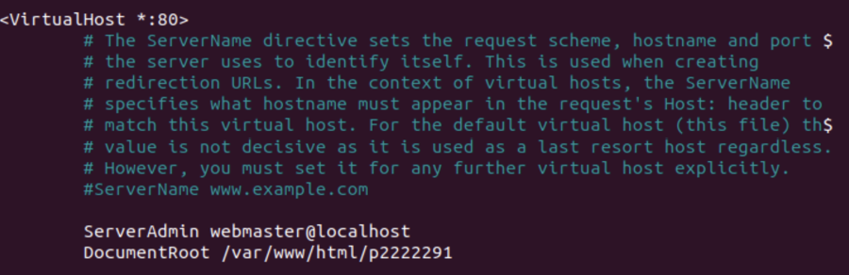

Grant file ownership of /var/www and its content to www-data user



Check the owner of the directory of /var/www

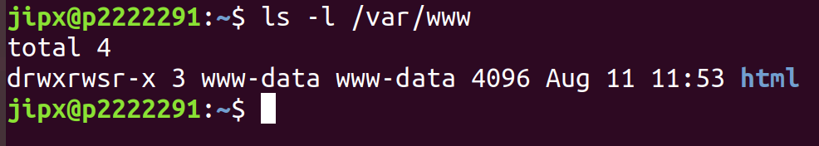

1. Grant group ownership of /var/www and its content to www-data group
2. Change the directory permissions of /var/www and its subdirectories to add group write permissions and to set the group ID on future subdirectories.
3. Change the file permissions of /var/www and its subdirectories to add group write permissions

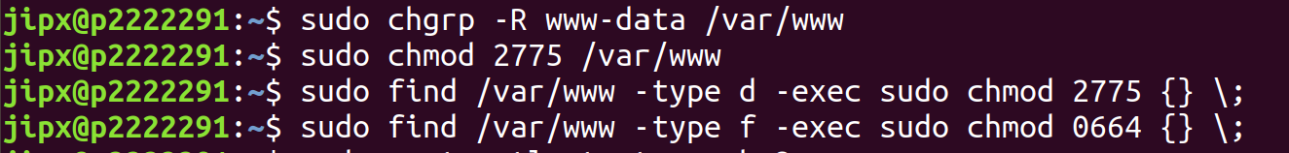

Restart Apache web server to pick up the new group and permissions

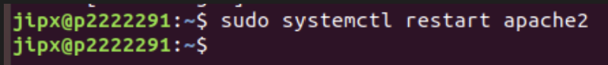

Running the WordPress installation script

Use chkconfig command to ensure that the httpd and database services start whenever the system boots.

Then Verify that the database server is running

(If database service is not running run the command:

*sudo systemctl start mysql)*

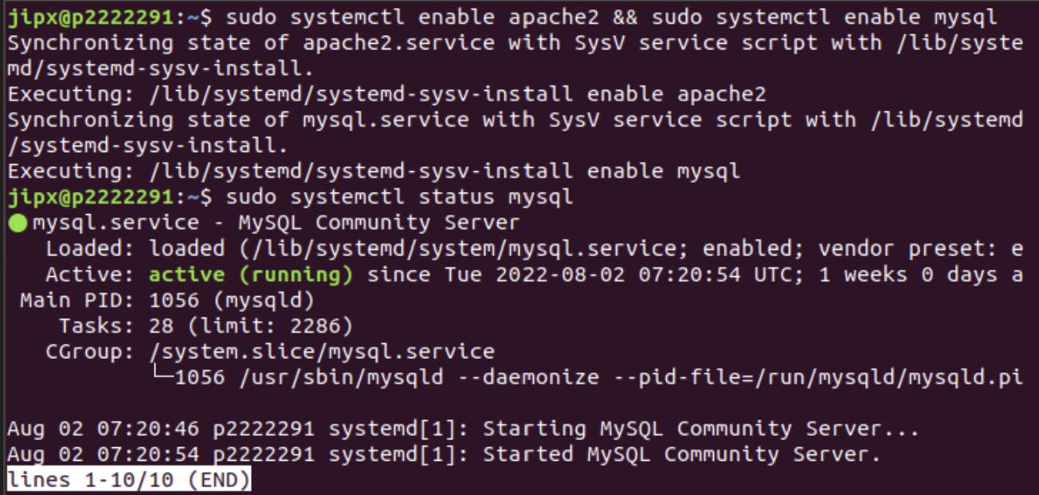

Verify that Apache web server is running

(If Apache web server is not running, enter command:

*sudo systemctl start apache2*)

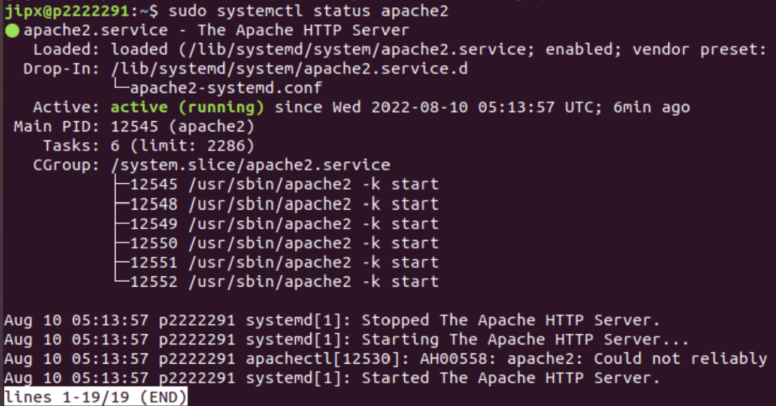

Now, go to a web browser and type the URL of your WordPress blog (public DNS address for your instance or that address followed by the blog folder).

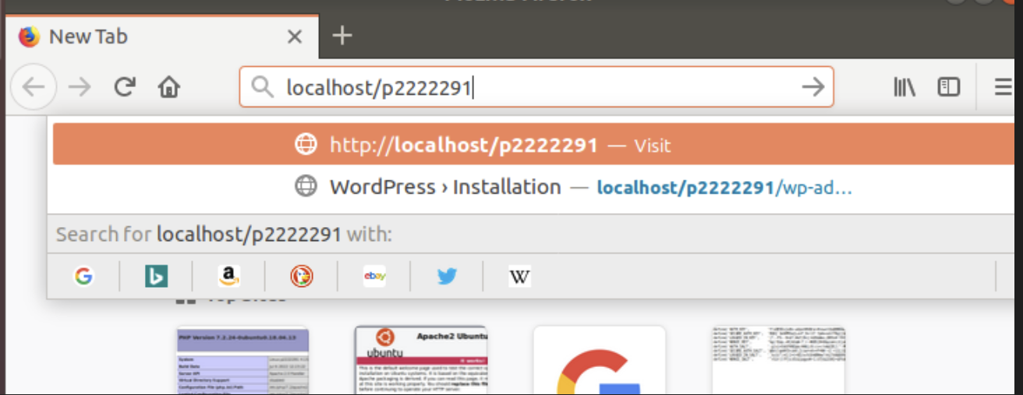

You should see a screen something like this

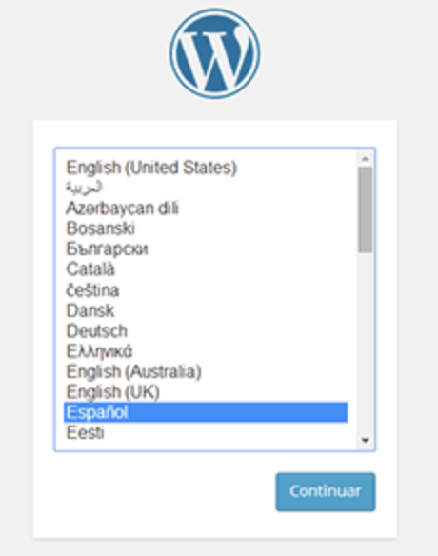

Enter your particulars then press Install WordPress, you should be brought to an Installation Success Page.

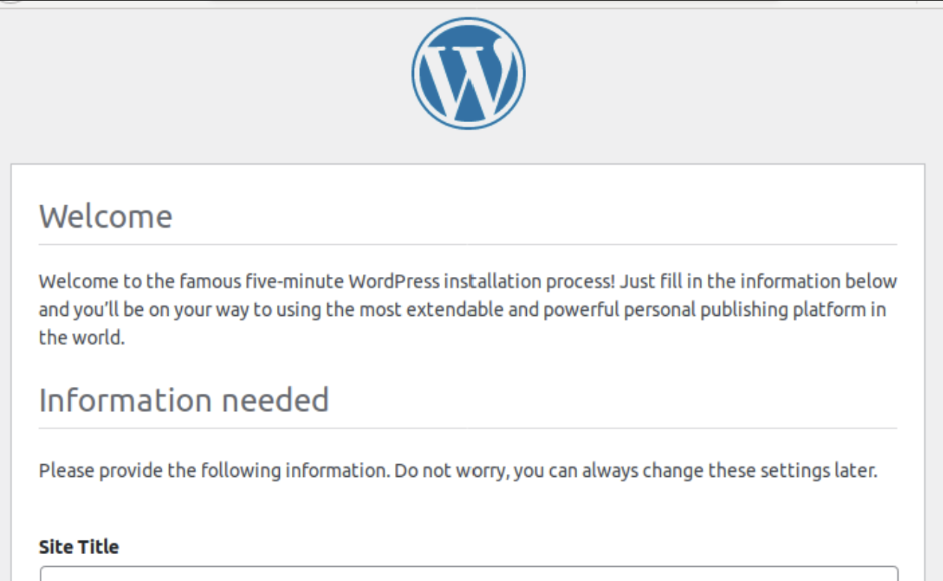

Login to your account

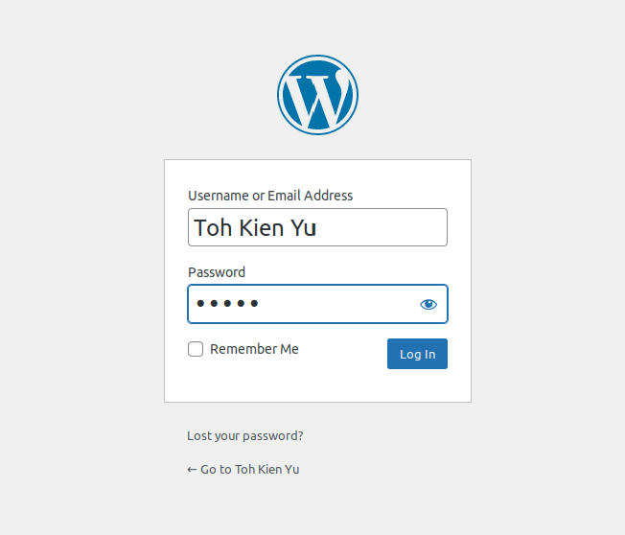

You should see a screen like this upon logging into your account.

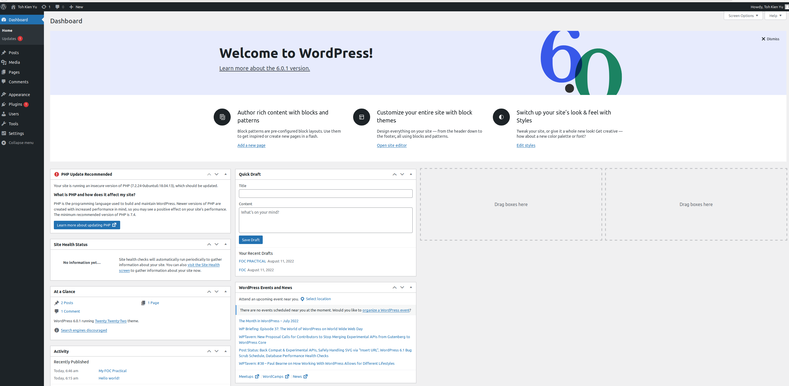

Part 5: Upload Practical Lab Documents and design website to make it easier for users to use.

My Website:

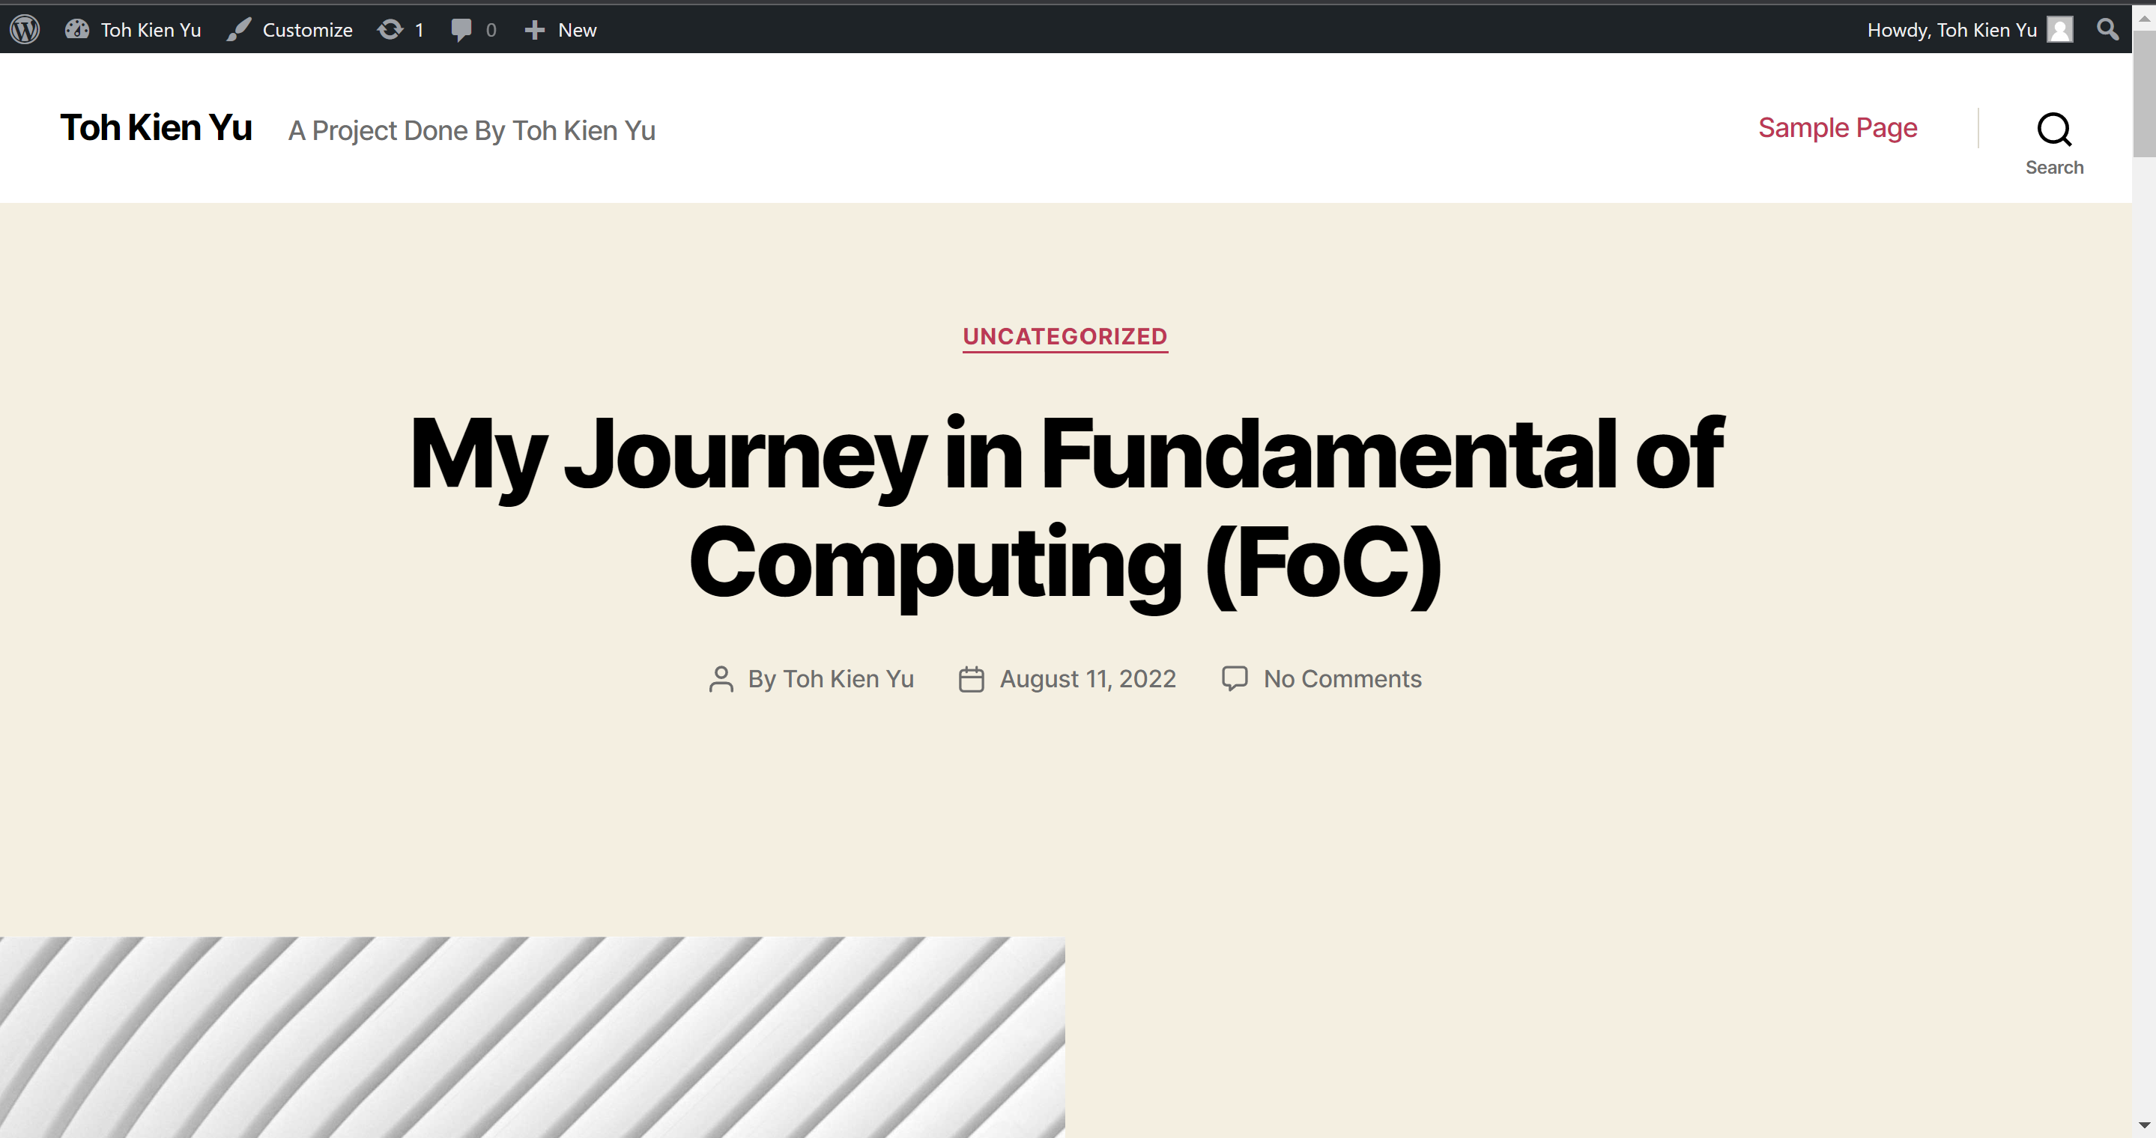

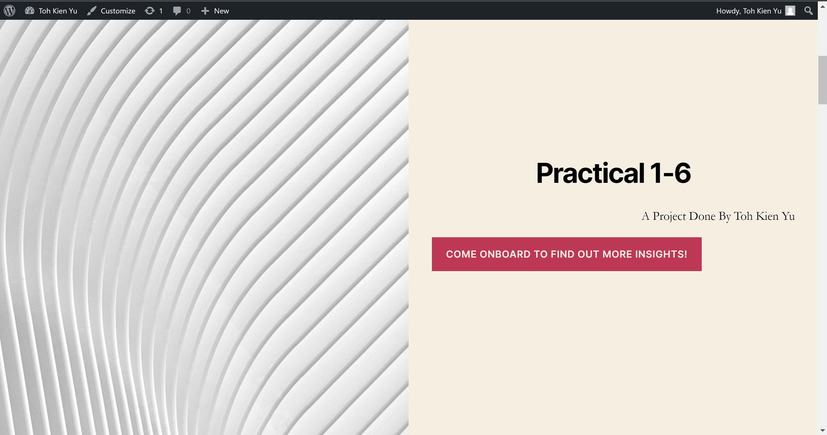

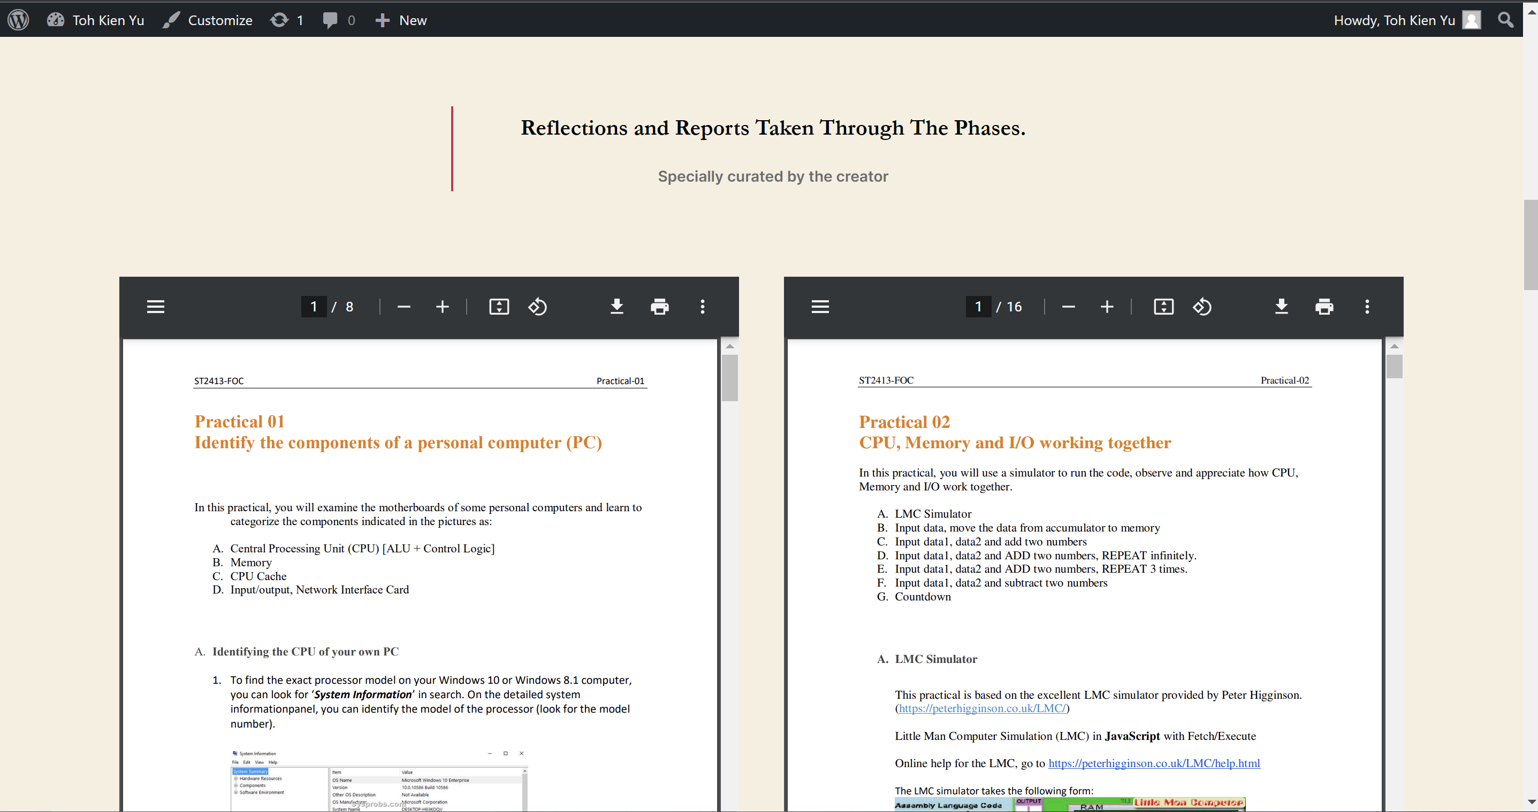

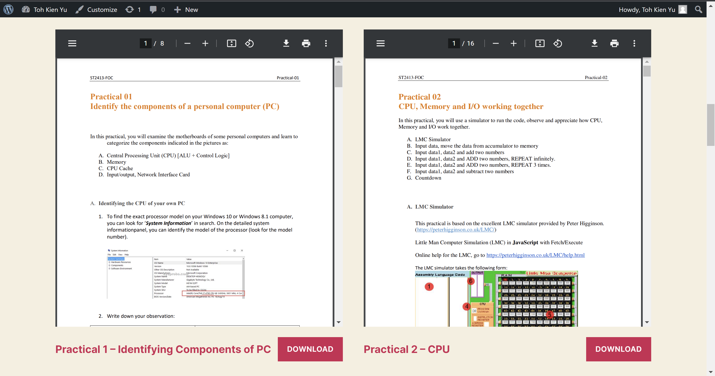

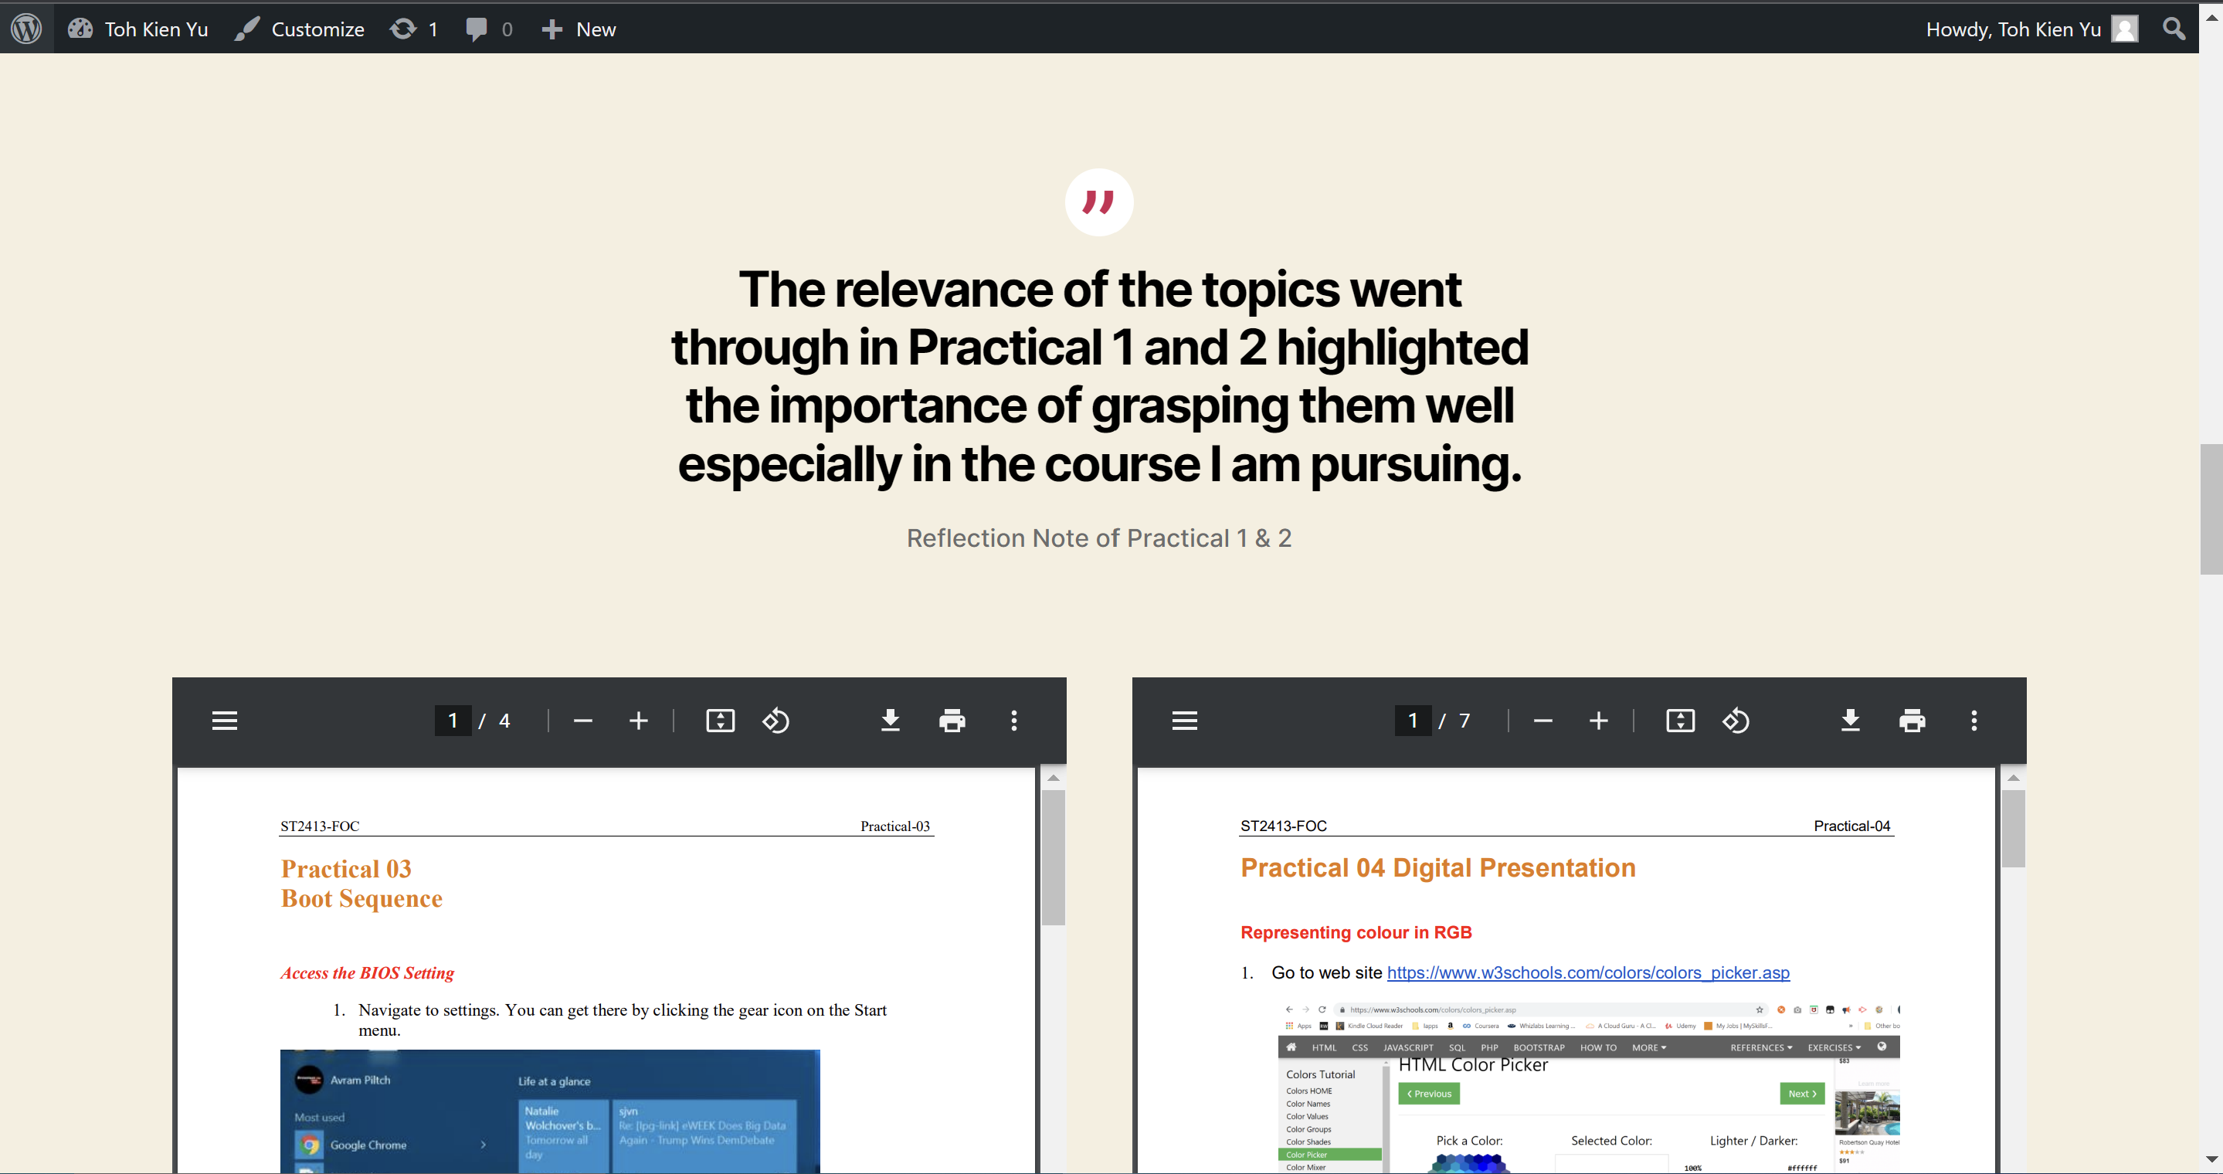

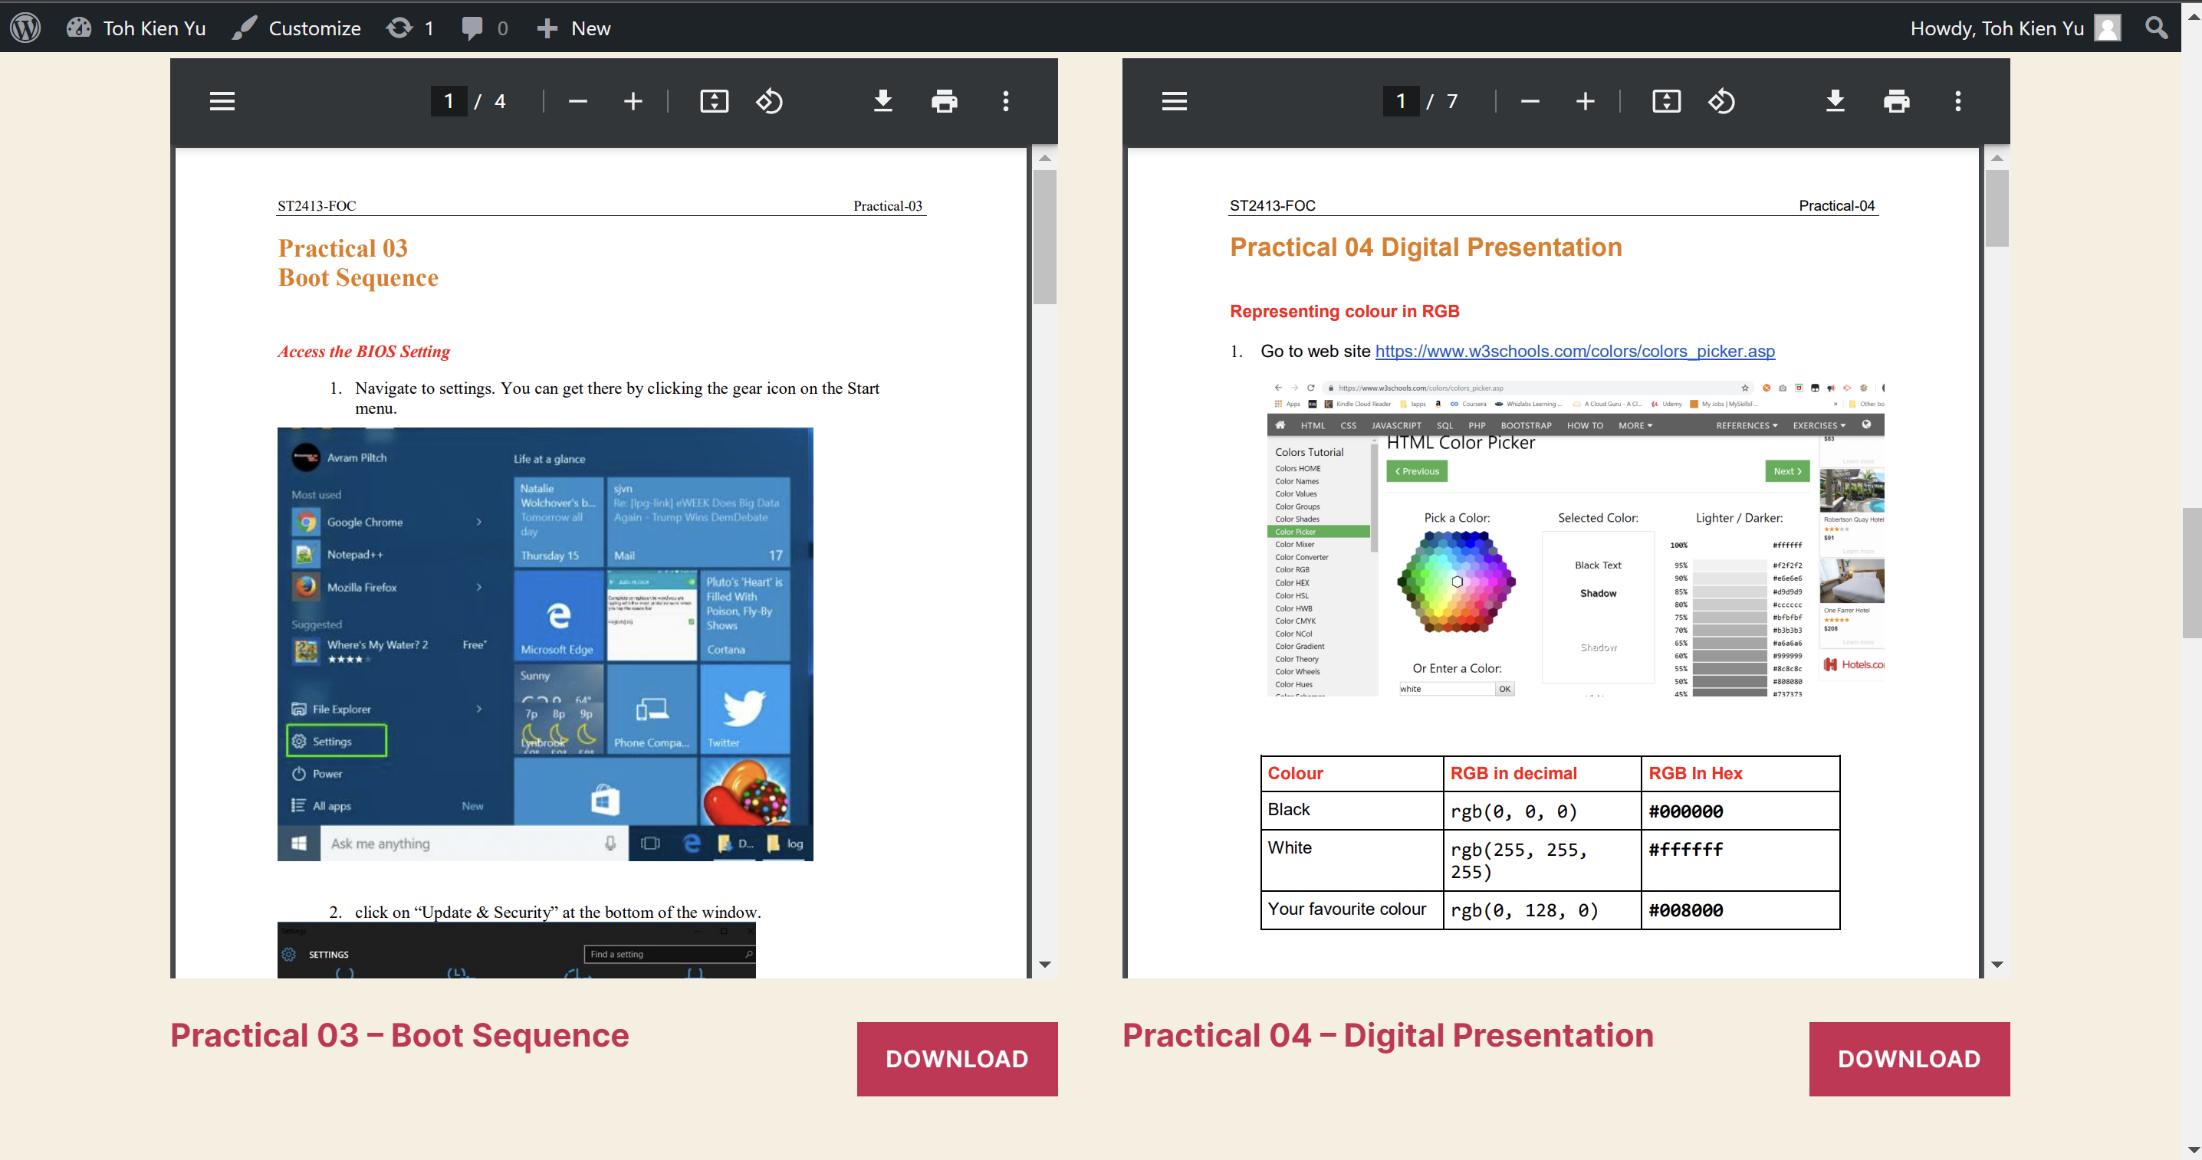

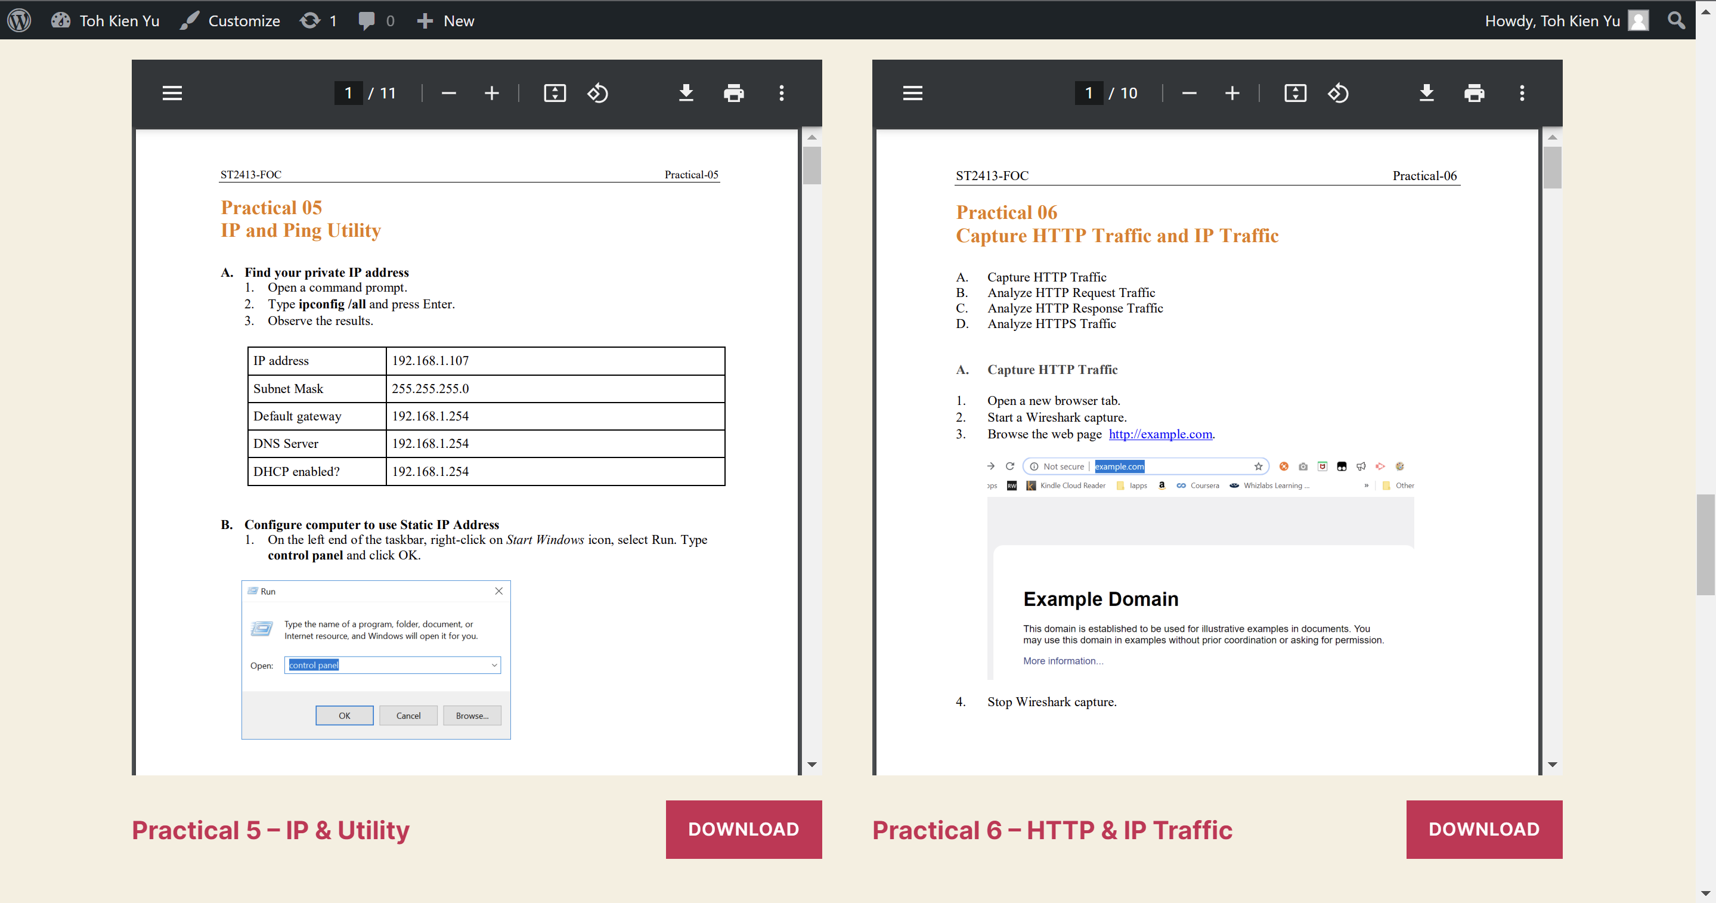

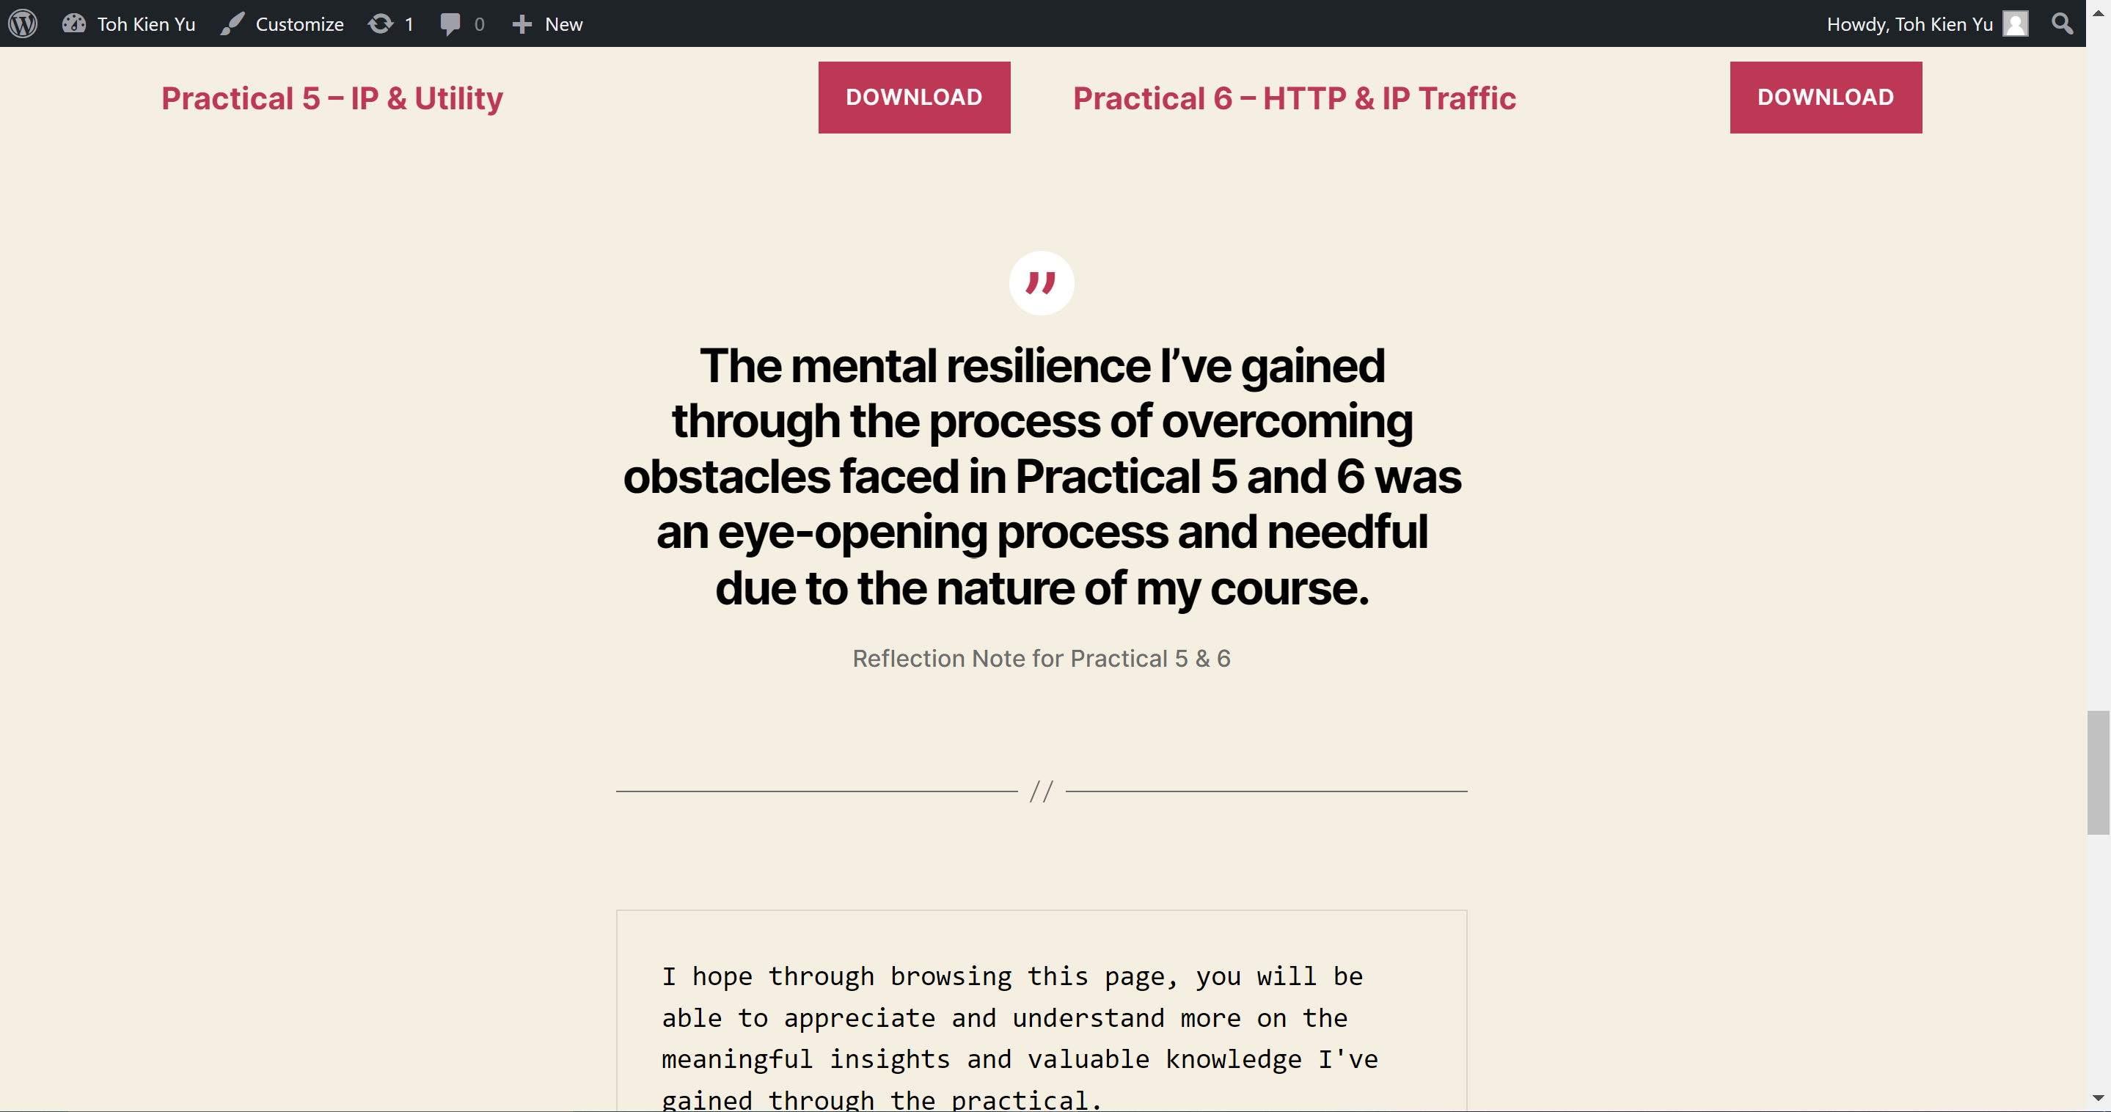

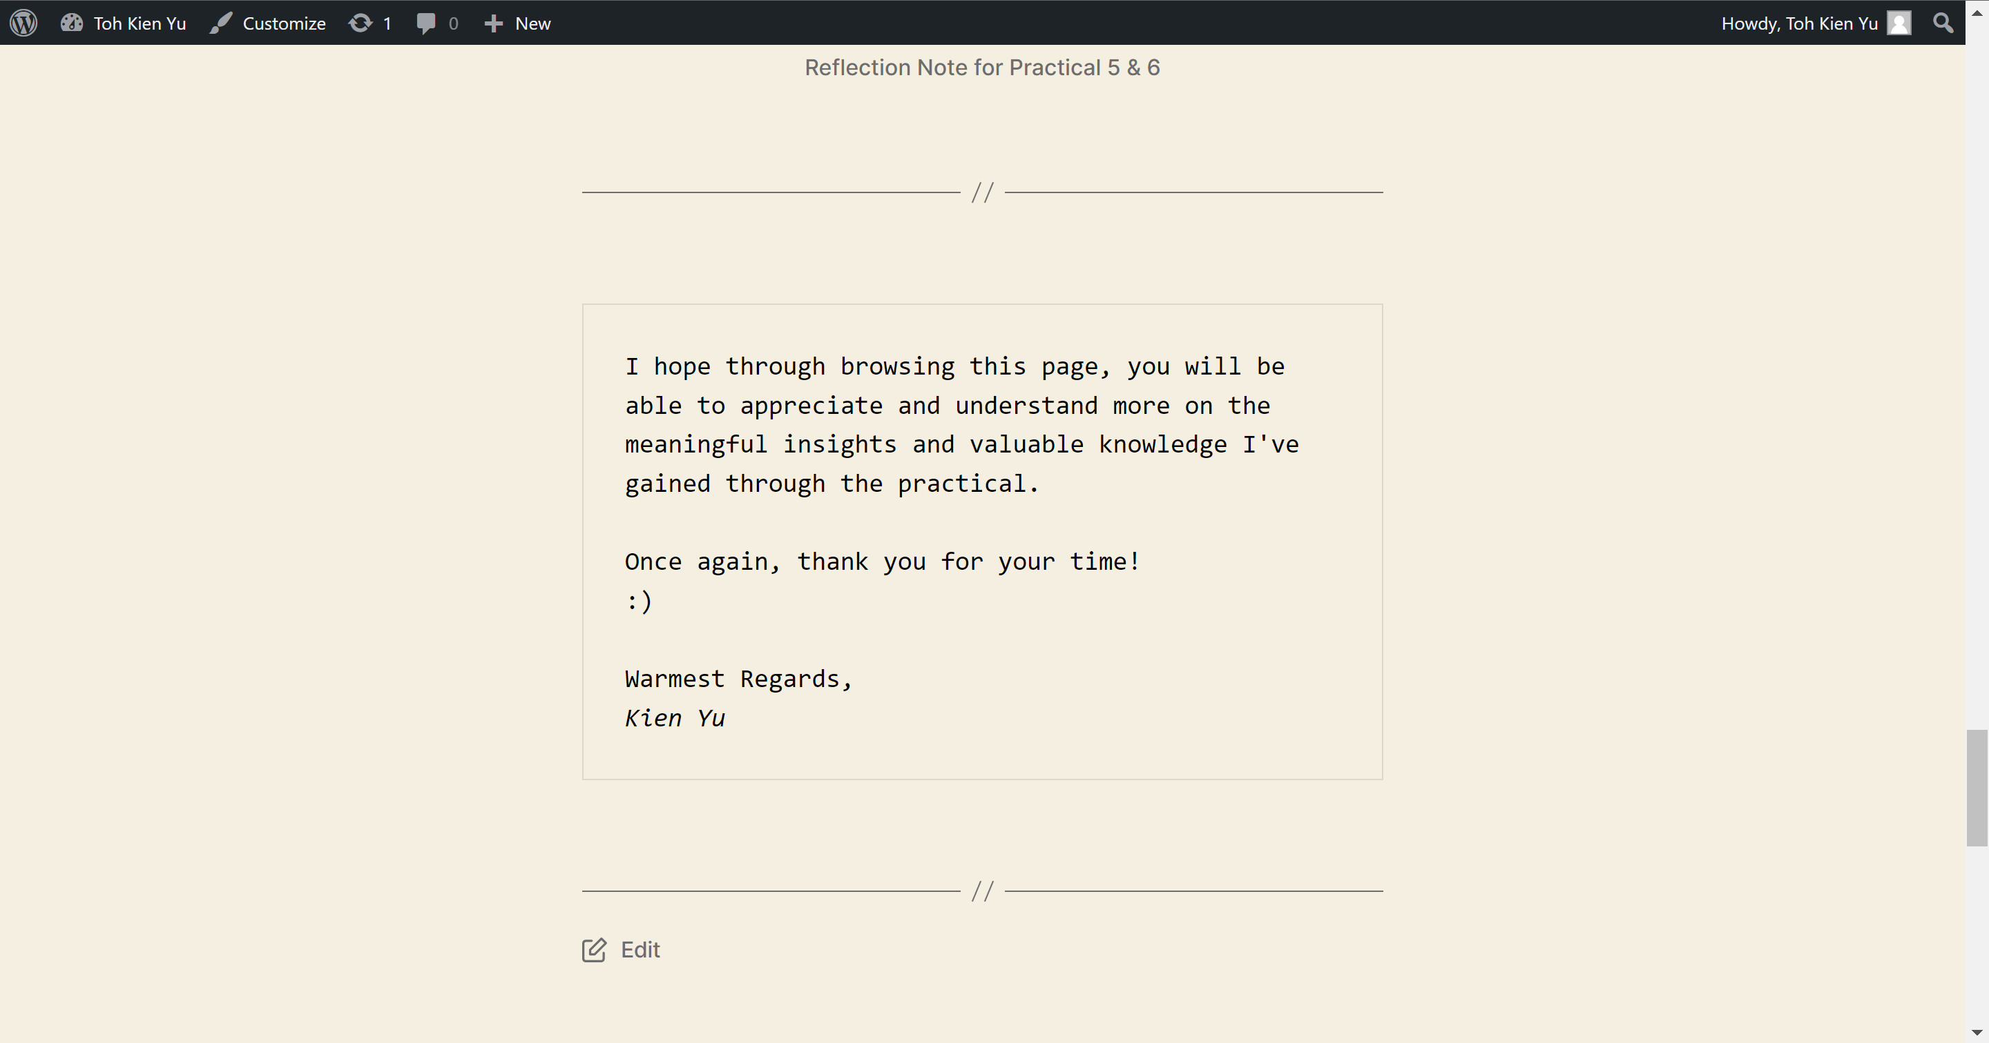

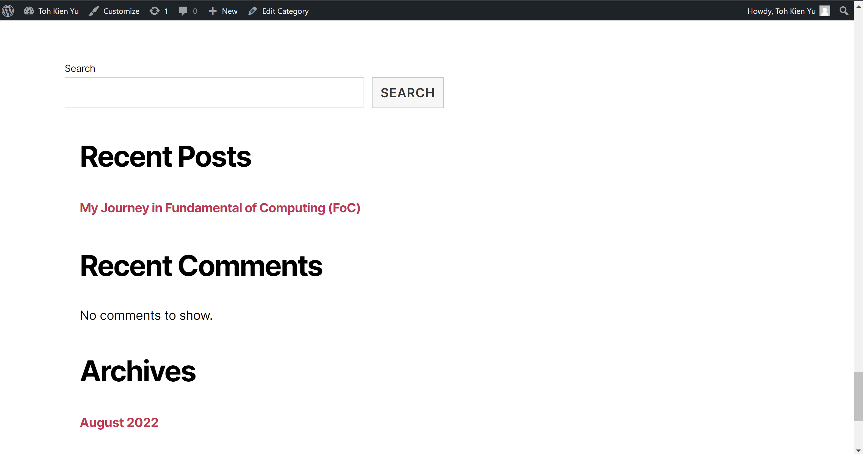

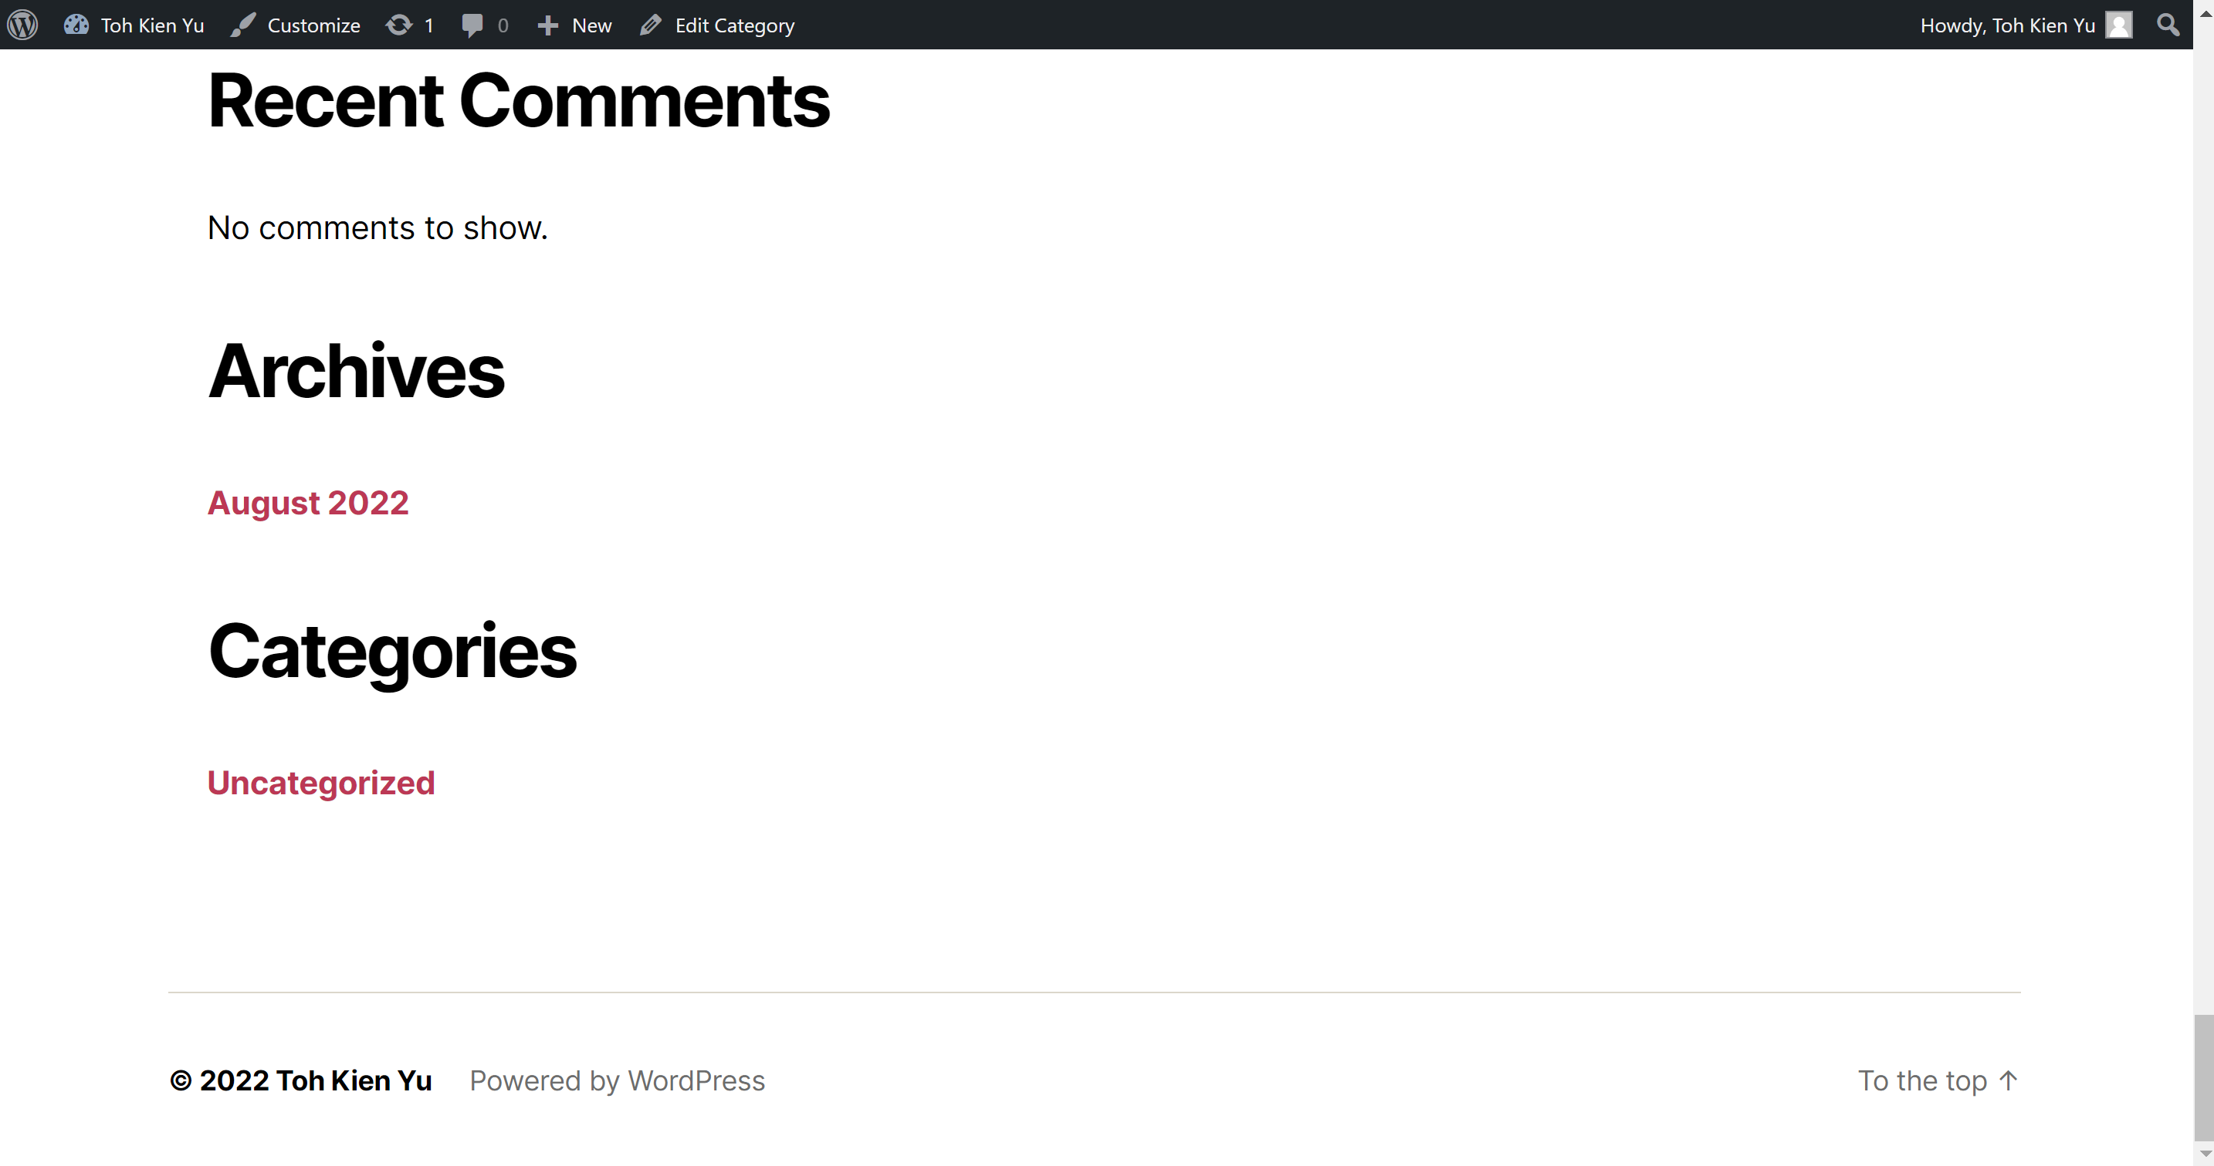

Part 6: Backup your local Ubuntu server and WordPress web site for recovery in case of failure

1. Hover over VM
2. Go to Snapshot
3. Press take Snapshot to back up your local Ubuntu server and WordPress website for recovery in case of failure.

